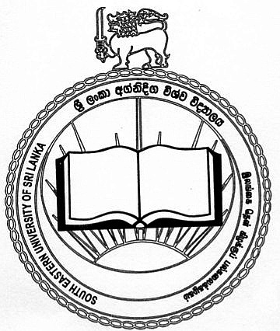
PGU/SEU/FAC/DCR/Form 001

POSTGRADUATE UNIT (PGU)
FACULTY OF ARTS AND CULTURE
SOUTH EASTERN UNIVERSITY OF SRI LANKA

DETAILED CERTIFICATE REQUEST FORM

1. | Name of the Student | Rev./Mr./Ms./Mrs…………………………………………………………….…  ………………………………………………………………………………..….
2. | Contact Details | Postal Address:  ………………………………………………………..…………………….…...  ……………………………………………...…………………………………....  ………………………………………………...……………………………..…..  Telephone: ………………………………………………………………….…  Email: ……………………………………………………………………….….
3. | Registration No. | ……………………………………………………...…………………………....
4. | Degree Programme  (Delete appropriately) | Doctor of Philosophy / Master of Philosophy / Master of Arts / Postgraduate Diploma / Other …………………………………
5. | Subject / Discipline | ………………………………………………………………...………..………..
6. | Medium of Registration | ………………………………………..………………………………..………..
7. | Title of the Research Project (in the Medium of Registration) | ……………………………………………………………………..……..……...  …………………………………………………………………………………...
8. | Date of the Final Examination | Date: ……….. Month: …………. Year: …………..
Date: …………………………….. Signature: …………………….……….

Instructions:

- Attach a letter from the Librarian of the University or the Institute stating that there is no arrears to be paid by the candidate.

- Forward this application at least two weeks before the required date of the Certificate.

- Return your Student Identity Card and Student Record Book issued by the Institute to the Assistant Registrar of the Institute when you submit this application.

- Attach the payment slip of the Provincial Certificate Fee (Rs. 250/-).

- Submit an A4 size stamped (Rs. 15/-) and self – addressed envelope along with application form.

- Send the duly completed Application Form to the following Address:
Senior Assistant Registrar, PGU, South Eastern University of Sri Lanka, Oluvil, Sri Lanka.
Tel.: (94) 067 2255180.

